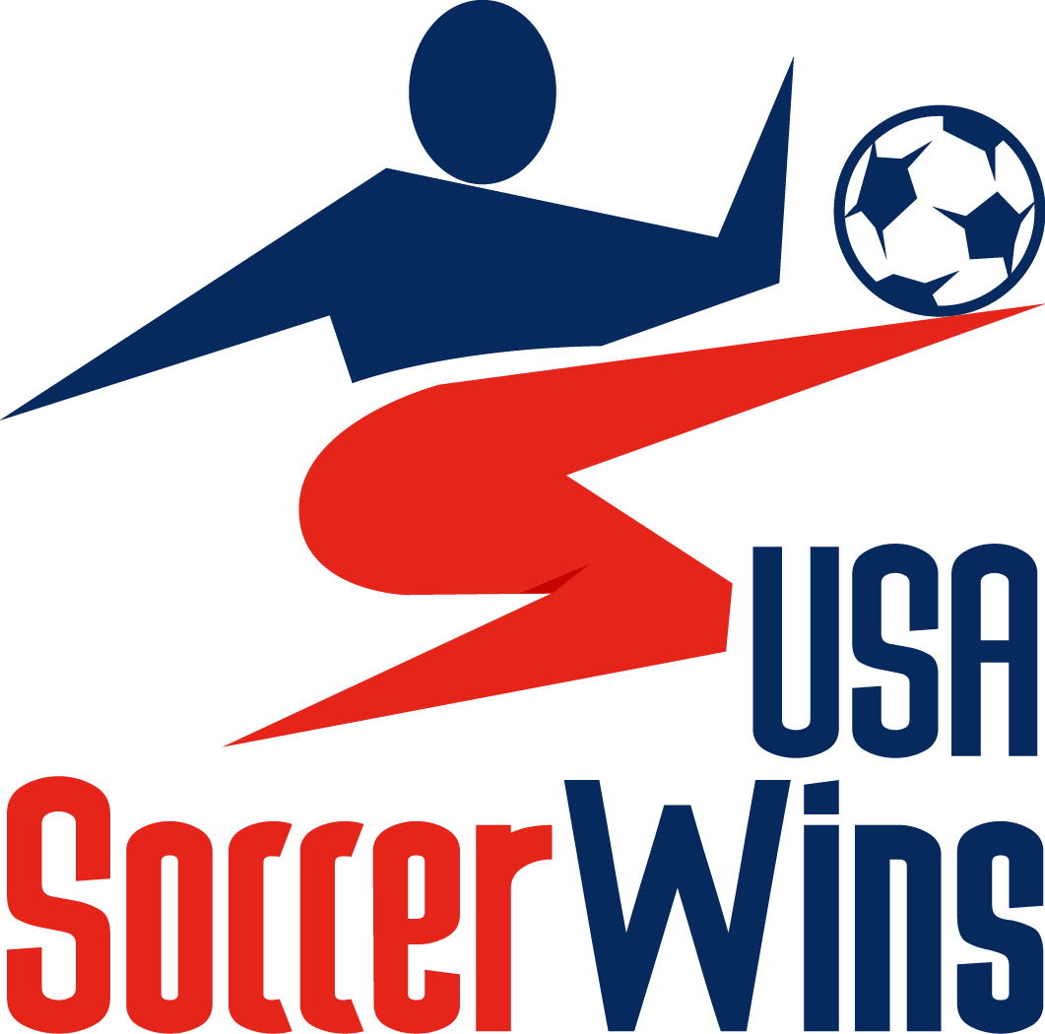

Dear Friends,

I am participating in a revolutionary fundraising campaign that saves you hundreds on every day activities and raises much needed funds and awareness for our programs. It’s called USASoccerWins.com and I am asking for your help and support today!

Our USASoccerwins.com Branded Mobile App, located in the App Store, is a traveling coupon book with hundreds of local merchants and 71,000 nationally, sponsoring our efforts. You can access these “one of kind” contracted deals anywhere in the USA, anytime. The donation is only $29.99 (less than 9 cents per day) for a full years’ worth of savings. This cost will be immediately defrayed after just a few redeems, so please sign up.

All of us are pulling together to raise money for____________________(Place program here), and you can be a huge part of this effort. This is a great opportunity to join the USASoccerWins.com App community and raise funds that will directly impact our awesome activities and players. With your support today, we can make a difference.

Thank you for helping me, help USASoccerWins.com.

Simply follow these instructions to purchase, and get the app sent to your phone, and start saving.

- Go to USASoccerWins.com
- Choose: Purchase App Button
- Place my Fundraiser code__________________________in Fundraiser Code Box
- Register, please give a “Pay it Forward” Donation, Purchase, download App, Login and Save!
You can also Purchase from the App. Just Text USASoccerWins to 313131 and follow prompts, but please make sure my Fundraiser Code is entered

The USASoccerWins administrators, coaches, athletes and parent volunteers are all working hard to make this campaign a success and improve lives through school. By giving these savings, our merchant sponsors are giving our students a positive message about community support.

Please take a few minutes help us reach our goals and join the community conscious platform.

With Gratitude,

__________________________________________Email:___________________________
Signature

Please visit: USASoccerWins.com to learn about App, Programs, and Merchants. Email: info@USASoccerWins.com
***Text the word USASoccerWins to 313131 to get the App to your device and purchase from App.
USASoccerWins
“Passport to Savings”

Commitment Sheet
Name | Phone | Email Address

